Titel

Underrubrik

Författare

© Författare,   
Institution  
Högskolan Väst  
461 32 Trollhättan.

E-post till korresponderande författare:  
[epostadress@hv.se](mailto:epostadress@hv.se)

Sammanfattning

#### (Rapportens titel)

(Sammanfattningen får inte överstiga en sida.)

**Nyckelord:** 5 st

Abstract

#### (Title of the report)

(The Abstract mustn´t exceed one page.)

**Keywords:** 5 words

Förord

(Om det är fler än en författare måste respektive författares bidrag till rapporten tydligt framgå i förordet.)

(Förordet får inte överstiga en sida.)

Innehållsförteckning

Rubriknivå 1 3

Rubriknivå 2 3

Rubriknivå 3 3

References 3

Appended Papers Error! Bookmark not defined.

**Innehållsförteckning: Högerklicka på innehållsförteckningen och välj “update field” > “update entire table” för att få innehållsförteckningen att stämma.**

# Rubriknivå 1

On the Insert tab, the galleries include items that are designed to coordinate with the overall look of your document. You can use these galleries to insert tables, headers, footers, lists, cover pages, and other document building blocks. When you create pictures, charts, or diagrams, they also coordinate with your current document look.

## Rubriknivå 2

On the Insert tab, the galleries include items that are designed to coordinate with the overall look of your document. You can use these galleries to insert tables, headers, footers, lists, cover pages, and other document building blocks. When you create pictures, charts, or diagrams, they also coordinate with your current.

### Rubriknivå 3

Lorem ipsum dolor sit amet, consectetuer adipiscing elit. Maecenas porttitor congue massa. Fusce posuere, magna sed pulvinar ultricies, purus lectus malesuada libero, sit amet commodo magna eros quis urna.

Nunc viverra imperdiet enim. Fusce est. Vivamus a tellus.

Pellentesque habitant morbi tristique senectus et netus et malesuada fames ac turpis egestas. Proin pharetra nonummy pede. Mauris et orci.

#### Rubriknivå 4

Lorem ipsum dolor sit amet, consectetuer adipiscing elit. Maecenas porttitor congue massa. Fusce posuere, magna sed pulvinar ultricies, purus lectus malesuada libero, sit amet commodo magna eros quis urna.

Nunc viverra imperdiet enim. Fusce est. Vivamus a tellus.

Pellentesque habitant morbi tristique senectus et netus et malesuada fames ac

Lorem ipsum dolor sit amet, consectetuer adipiscing elit. Maecenas porttitor congue massa. Fusce posuere, magna sed pulvinar ultricies, purus lectus malesuada libero, sit amet commodo magna eros quis urna.

Nunc viverra imperdiet enim. Fusce est. Vivamus a tellus.

Pellentesque habitant morbi tristique senectus et netus et malesuada fames ac turpis egestas. Proin pharetra nonummy pede. Mauris et orci.

Aenean nec lorem. In porttitor. Donec laoreet nonummy augue.

Suspendisse dui purus, scelerisque at, vulputate vitae, pretium mattis, nunc. Mauris eget neque at sem venenatis eleifend. Ut nonummy.

Fusce aliquet pede non pede. Suspendisse dapibus lorem pellentesque magna.

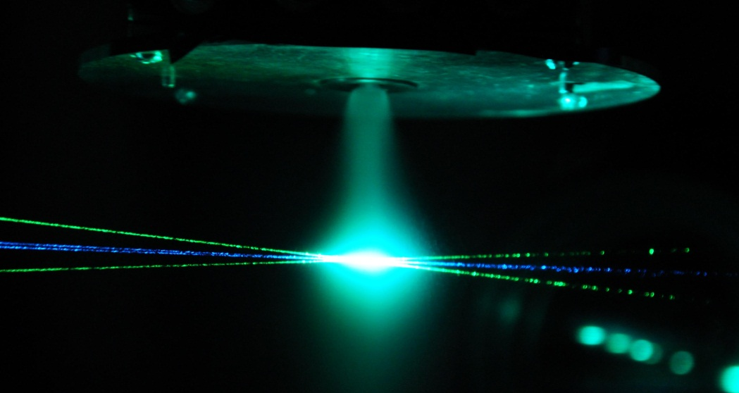

Figur 1. Detta är en figurtext.

Lorem ipsum dolor sit amet, consectetuer adipiscing elit. Maecenas porttitor congue massa. Fusce posuere, magna sed pulvinar ultricies, purus lectus malesuada libero, sit amet commodo magna eros quis urna. Lorem ipsum dolor sit amet, consectetuer adipiscing elit. Maecenas porttitor congue massa. Fusce posuere, magna sed pulvinar ultricies, purus lectus malesuada libero, sit amet commodo magna eros quis urna.

Lorem ipsum dolor sit amet, consectetuer adipiscing elit. Maecenas porttitor congue massa. Fusce posuere, magna sed pulvinar ultricies, purus lectus malesuada libero, sit amet commodo magna eros quis urna.

Lorem ipsum dolor sit amet, consectetuer adipiscing elit. Maecenas porttitor congue massa. Fusce posuere, magna sed pulvinar ultricies, purus lectus malesuada libero, sit amet commodo magna eros quis urna. Lorem ipsum dolor sit amet, consectetuer adipiscing elit. Maecenas porttitor congue massa. Fusce posuere, magna sed pulvinar ultricies, purus lectus malesuada libero, sit amet commodo magna eros quis urna.

Lorem ipsum dolor sit amet, consectetuer adipiscing elit. Maecenas porttitor congue massa. Fusce posuere, magna sed pulvinar ultricies, purus lectus malesuada libero, sit amet commodo magna eros quis urna.

Tabell 1. Detta är en tabelltext

|  |  |  |  |
| --- | --- | --- | --- |
| Manipulations Scenario 3 (Copying text without using citation) | n | m | Sd |
| Control | 38 | 5.47 | 0.89 |
| Man | 35 | 5.28 | 1.11 |
| Woman | 37 | 4.97 | 1.32 |
| Reading and writing difficulties | 30 | 5.33 | 0.99 |
| Other ethnic background with some language difficulties | 44 | 5.45 | 1.02 |
| Much experience of university studies from home | 35 | 5.71 | 0.57 |
| No previous experience of university studies from home | 30 | 4.97 | 1.35 |
| Total | 249 | 5.32 | 1.08 |
|  |  |  |  |

You can easily change the formatting of selected text in the document text by choosing a look for the selected text from the Quick Styles gallery on the Home tab. You can also format text directly by using the other controls on the Home tab. Most controls offer a choice of using the look from the current theme or using a format that you specify directly.

# Referenslista

[Ali R. Abasi](http://www.sciencedirect.com/science/article/pii/S1060374306000257), A. R., Akbari, N. & Graves, B. (2006). Appropriation, construction of identities, and the complex issue of plagiarism: ESL students writing in graduate school.[*Journal of Second Language Writing*](http://www.sciencedirect.com/science/journal/10603743)***,*** [15, 2](http://www.sciencedirect.com/science/journal/10603743/15/2), p 102–117.

Babic, S. (2005). *Plagiering inom högre studier*. Forskningsrapport i Plagiatprojektet. Gävle: Högskolan i Gävle.

# Bilagor