Template for project report

Author 1 Author 2 Author 3 Author 4

Optional picture - max width 16 cm and height 8 cm
Remove this frame if no picture is used.

Preface

Write the same title as on the title page

Abstract
Date: September 8, 2023
Author(s): Author 1, Author 2, Author 3, Author 4
Course: XXX000 Course name (see the course syllabus)
Examiner: Arthur Dent
University West, Department of Engineering Science, S-461 86 Trollhättan, SWEDEN

Contents
Preface i
Abstract ii
Nomenclature iv
1 Heading 1 1
1.1 Heading 2 1
1.1.1 Heading 3 1
2 Heading 1 2
2.1 Heading 2 2
2.2 Heading 2 2
2.2.1 Heading 3 2
2.2.2 Heading 3 2
2.3 Heading 2 2
2.3.1 Heading 3 2
2.3.2 Heading 3 2
References 3
Appendices 4
A: First appendix heading A:1
B: Second appendix heading B:1

Figures
Figure 1.1 A simple flow chart. 1

Tables
Table 1.1 The properties of two different fruits. 1

Nomenclature
Glossary
Acronym = Explanation
Specialist term = Explanation
Symbols
symbol = description [unit]

Greek symbol = description [unit]

Heading 1
Body Text

Heading 2
Body Text

Heading 3
Table 1.1 The properties of two different fruits.
 | Shape | Color | Taste
Banana | elongated | yellow | sweet
Lemon | round | yellow | sour

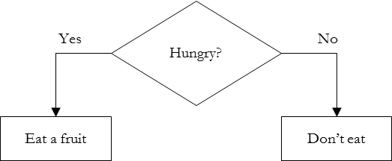
Figure 1.1 A simple flow chart.

Heading 4
Body Text

Heading 5
An equation
$$I_{0}=\frac{1}{2π}\int_{0}^{2π}{i\left(v\right)dv}$$ | (1.1)
and an equation template
$$=$$ | (k.l)

Heading 1
Body Text

Heading 2
Body Text

Heading 2
Body Text

Heading 3
Body Text

Heading 3
Body Text

Heading 2
Body Text

Heading 3
Body Text

Heading 3
Body Text

References

Appendices
See the following pages.

First appendix heading

Second appendix heading

