- To optimize your ORCID, fill in your affiliation / employment:

- To import information about your published works, choose Add works / Search & link and scroll down to the appropriate information source.
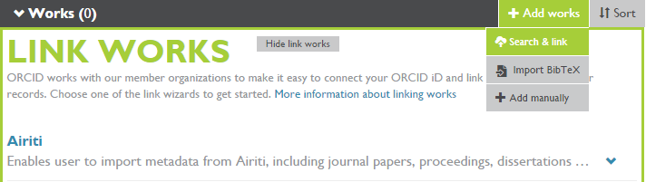

- And Authorize:
